CREYNOLDS LANE – SOUTH TOWARDS ILLSHAW HEATH ROAD

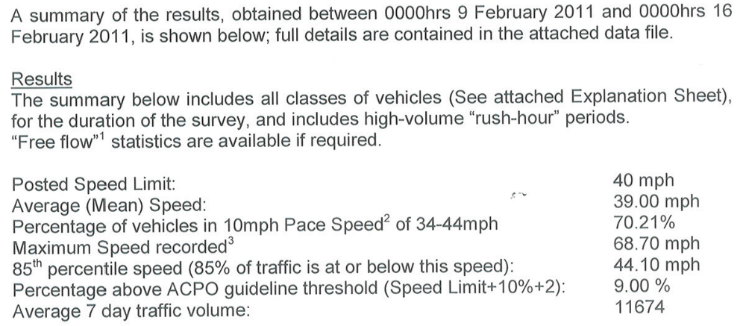

CREYNOLDS LANE – NORTH TO STRATFORD ROAD
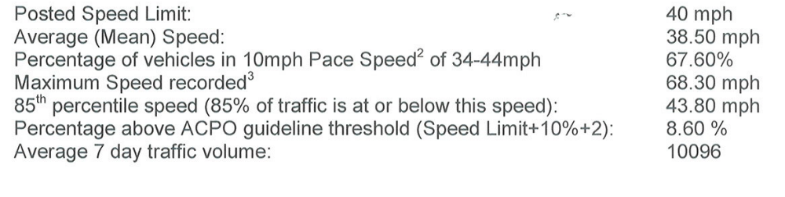

Data taken from report supplied by West Midlands Police Traffic Data Unit, Aston, Birmingham.
It is suggested that the maximum speed recorded is untypical of general speed and may even be an emergency vehicle recorded.

