Lyndon, Elmdon, Olton & Silhill (LEOS) MAVE 29/03/2017

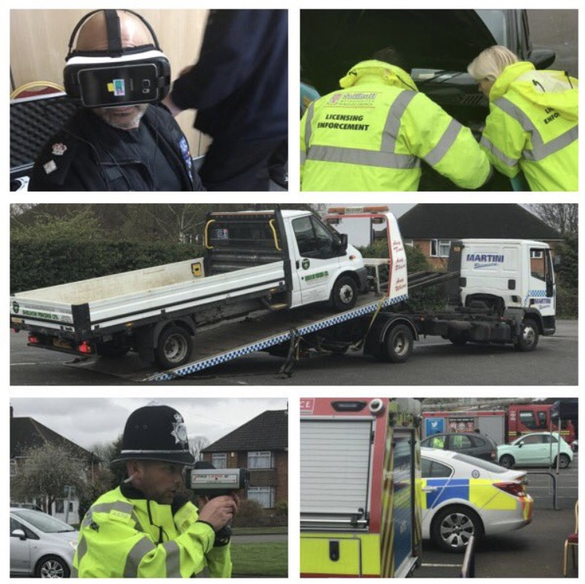

As part of our multi agency working; the responsible authorities of Solihull joined forces in the heart of the community again to promote road safety & reduce crime again on Wednesday 29th March 2017. The work involved officers and representatives from; West Midlands Fire Service (Blue Watch and Solihull Watch Commander), Solihull Licensing Department, Solihull Trading Standards, Solihull Neighbourhood Services including the community manager & Co-ordinator, NSL Civil Parking enforcement team, a representative from urban heard (youth engagement specialists) & West Midlands Police (neighbourhood teams including LEOS, & St Alphege together with the partnerships team & the Solihull Commander).

The joint work took place at key locations in Solihull and involved a high visibility presence of officers, all with the same aim of promoting road safety, reducing the potential for accidents, educating the motorist (or enforcing where necessary) as well as positive engagement within the community and providing reassurance around our schools and areas that had recently been subject of crimes.
West Midlands Police community support Officers & NSL Civil parking enforcement officers were on patrol first thing in the morning visiting schools including Langley Primary and Greswold Primary schools. Tickets were issued to motorists who ignored any restrictions including yellow zig zag lines and double yellows. A short briefing was then held at Solihull Ice rink on Ulleries Road where the day’s events were explained.

West Midlands Police officers then conducted a pro laser operation (speed gun) on Hobs Moat Road, stopping vehicles that were exceeding the 30mph speed limit as we had received a number of complaints about the speed of motorists using the road. In total 204 vehicles were measured for speeding and 18 were found to be exceeding the speed limit to such an extent that they were stopped and either put through an educational input from the fire service using the latest virtual reality headsets or (where the speed was so excessive) they were issued with an endorseable ticket. The range of speeds recorded were between below 30 through to 51 mph.

We remained at this location until 12:00 hours before breaking for lunch. At the same time that this work was taking place NSL Parking enforcement officers were patrolling key roads in the area to promote road safety, enforce any violations and deter crime. These roads included Hobs Moat Road, Ulleries Road, Warwick Road, Buryfield Road, Ferndown Road, Wherrets Well Lane, Lode Lane and Old Lode Lane.

Trading standards were also carrying out their weights and measures inspections on the BP Mereside petrol station on the Warwick Road, this location was due for inspection but the work was carried out to coincide with all of our work. All the other petrol stations in the immediate area were visited two days before the operation and managers were encouraged to put staff on the forecourt where possible to deter any deflected fuel thefts they may suffer due to the high visibility presence on the BP, all agreed to be extra vigilant and work with us on the day.

Trading Standards were kept busy as they were also conducting high visibility joint patrols with West Midlands Police in the same areas as the NSL officers. They visited many addresses where work was clearly being carried out and engaged with both the traders and consumers to ensure that the consumer rights act was being complied with and promote best practice in terms of preventing doorstep crime. They were also stopping any vehicles that were worthy of being stopped including a scrap metal collector that was operating in Solihull without the relevant license to do so.

The fire service engaged with 15 motorists that had been caught speeding and allowed them to take part in an educational input including the motorist observing first-hand the impact of their actions and the consequences it has on them, other motorists and the emergency services. This was done via the virtual reality headsets and the motorist was able to see the outcome of being involved in a road traffic collision.

At the same time as this was happening the Licensing team were conducting safety and compliance checks on all the private hire vehicles & Hackney carriages that were passing. Improving road safety, enforcing offences and advising drivers where necessary.

Solihull Neighbourhood services / co-ordinators & the community manager also joined us and conducted High Visibility patrols in the area. There was some real positive engagement from them with residents, letting them know what was happening in the area and also referring one good natured resident to the active citizens group for possible funding for an initiative they were running in the Lyndon area.

The pro laser operation then moved to Dovehouse Lane in Solihull at 13:15 where again motorist’s speeds were checked and where necessary offences were enforced including speeding, illegal number plates, not wearing seat belts and driving with no insurance. At Dovehouse Lane 229 vehicles were checked for their speed, 3 motorists were issued endorsable tickets for speeding, 3 motorists were issued tickets for illegal number plates, 1 motorist was issued a ticket for not wearing a seat belt and one vehicle was seized as the driver did not have any valid insurance.

NSL civil parking enforcement team also conducted joint patrols again in the afternoon with LEOS PCSO’s at two more schools: Ulverley Green primary and Yew Tree Primary school. Again a number of parents on the school run were engaged with and where necessary tickets were issued for parking on the yellow lines, zig zags or other restrictions.

The work at Solihull Ice rink commenced with a briefing at 09:30 and the first vehicle was pulled onto the site at 10:02, the last vehicle left the site at 12:05. During this time we stopped 31 vehicles (13 of which were taxis for inspections), the other vehicles were all stopped as a result of officers spotting offences in relation to either speeding or seat belts not being used.
In summary: 433 Vehicles were checked for their speed (both locations combined).
21 drivers were found to be speeding excessively (more than 20% above the speed limit)
1 vehicle was seized for no insurance
1 Vehicle was seized for no vehicle excise license (road tax)
6 drivers were issued endorsable fixed penalty notices for speeding
15 drivers were given an educational input by the fire service
3 drivers received a ticket for illegal number plates
2 drivers were issued tickets for not wearing their seat belts
NSL civil parking enforcement team issued 9 tickets for contravention offences
13 taxis were stopped and checked for compliance;
4 drivers received Officer Cautions for failing to wear their badge in the prescribed format.
1 diver cautioned for not displaying is PHV plate.
1 driver cautioned for not displaying his Hackney carriage fare table.
1 Wolverhampton HCV was suspended as one of the tyres was just below the legal limit (1.58mm). The tyre was changed by the driver onsite and the suspension was lifted. He was also one of the drivers cautioned for not wearing his badge. To be reported to Wolverhampton Council.
1 PHV licensed by us has been called back for a re-inspection 30/3 at 09:30 am.
2 Betting shops were also visited by Janette and Kerry, both found to be compliant.

The high visibility presence created by our joint work has left a positive footprint in the area of Solihull and this was clearly reflected in the reduction of overall crime. We had a reduction in key crimes we were targeting (burglaries, vehicle crime and fuel thefts). The work was also broadcast on social media live as it was happening and received positive comments asking for these type of events to be held more often.

